SARDAR VALLABHBHAI NATIONAL INSTITUTE OF TECHNOLOGY, SURAT
DEPARTMENT OF CIVIL ENGINEERING
GEOTECHNICAL ENGINEERING SECTION
GEOSYNTHETICS TESTING LABORATORY
Geosynthetics testing laboratory was established in the year 2022. The laboratory is located in the B wing of Department of Civil Engineering. The laboratory facilities are utilized by undergraduate and postgraduate students for their curriculum laboratory work. The research scholars also utilize it for the research and development activities. Set ups like Universal Testing Machine for Geosynthetics testing is used for some of the consultancy work. It is one of the key laboratory for UG/PG courses working with majority of available set ups. List of equipment available in the laboratory is given below:
Sr. No. | Equipment Name
1 | Computer Controlled Universal Testing Machine for Geosynthetics testing (Capacity 100 kN) with attachment for following test
2 | Cone Drop Test Apparatus
3 | Cross Permeability Test Apparatus
4 | In-Plane Permeability Test Apparatus
5 | Thickness Gauge for Geotextile
6 | Dry Sieve Test Apparatus
7 | Hydrodynamic Sieve Test Apparatus with two drum type

Information Regarding Few Important Set Ups in the Geosynthetics Testing Laboratory
Computer Controlled Universal Testing Machine for Geosynthetics testing (Capacity 100 kN) with attachment for following test: -
Narrow and Wide-Width Tensile Strength, Grab Tensile Strength Test, Trapezoidal Tear Resistance Test, CBR Push Through Test,
Specialties
- Geo-synthetic (Geotextile, Geomembrane, Geogrid, Geonet etc.) material testing in tension as well compression.
- Suitable to conduct Grab, Puncture, Tearing, CBR Push through, wide width Tensile tests conforming to the testing procedure laid down in various standards.
- Also, suitable to conduct tensile/ compression/ bend test on different materials such as Rubbers, Cables, Fabrics, Tapes, Thread, Plastic etc.
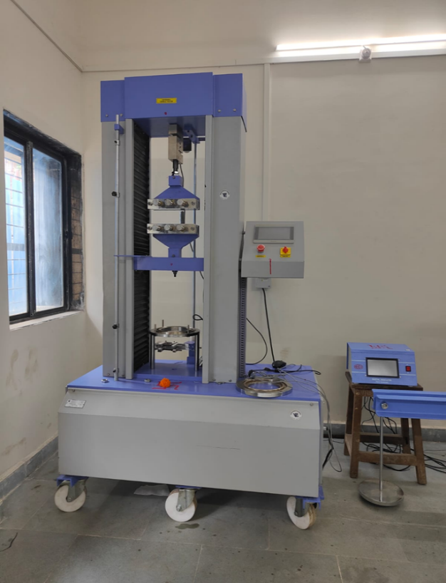
Figure 1 Universal testing machine for Geosynthetics

